**Project Synopsis: IoT Based Security System**

**Introduction:**

The IoT based smart security system for campus is designed to enhance security measures by leveraging interconnected device and smart sensors. It aims to monitor and secure campus premises effectively. Ensuring the safety of students, faculty, and staff members.

**Objective:**

The primary objective of this project is to implement security system using IoT technology to detect unauthorized access, monitor real time activities, and provide timely alerts and report to concerned authorities.

**Scope:**

The scope of the project includes integrating various IoT devices such as sensors (Gas & Fire Sensor), Cameras (Real time surveillance), RFID based smart locks, and alarm systems for intrusion detection at night to create a cohesive security infrastructure. The system will utilize Wi-Fi networks for seamless communication and protocols like MQTT or HTTP for efficient data exchange.

**Problem Definition:**

Current campus security systems often lack real-time monitoring capabilities and fail to provide comprehensive alerts for unauthorized access, fire, or environmental hazards. This project addresses these shortcomings by implementing a robust IoT-based solution.

**Hardware Requirements:**

**Component List:**

1. ESP32
2. MFRC522 RFID Reader & Tag
3. Gas Sensor
4. Fire Sensor
5. ESP CAM
6. Reed Switch

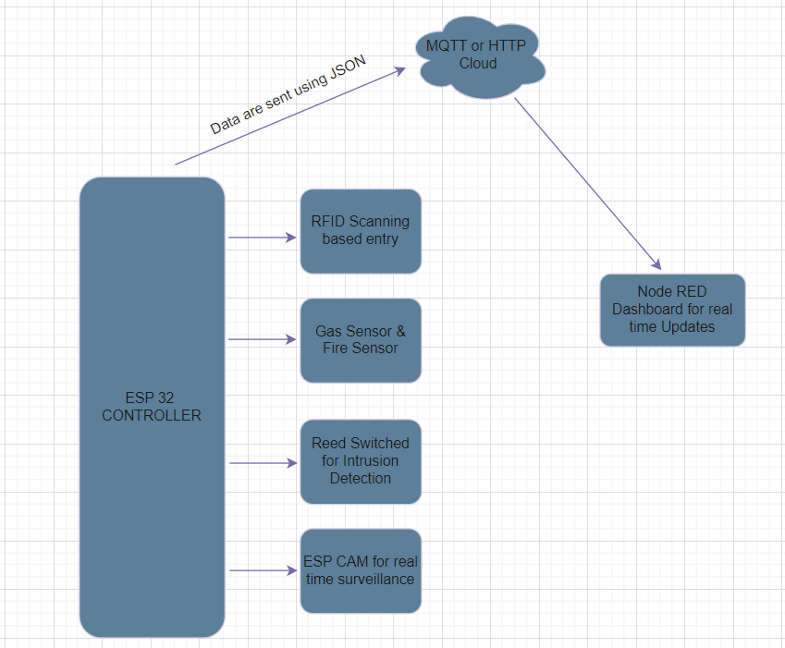

Architecture of the System

**Software Requirement:**

1. Node RED Based Web Applications: To monitor and control the IoT devices and security system.
2. Data Protocol: MQTT or HTTP for communication between IoT devices and the central monitoring system.
3. Arduino IDE for programming the controller.

**Conclusion:**

The IoT-based Smart Security System for Campus aims to significantly improve campus security by providing real-time monitoring, early detection of potential threats such as unauthorized access, fire, and environmental hazards. By implementing this system, the safety and security of campus inhabitants will be enhanced, reducing risks associated with theft, vandalism, and emergencies.